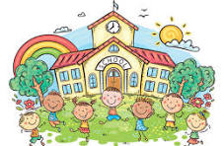

**First Grade Syllabus**

**Teacher: Mrs. Hurley**

**School Year: 2024-2025**

**Goals for the Year: The most significant reading goal for this year is for your child to become a fluent**

**and independent reader. This includes decoding words as well as comprehension. The goal for writing**

**is that your child will leave first grade being able to write a solid paragraph. The major mathematic**

**goals include being able to count forward and backwards, addition, subtraction, measurement, and**

**problem solving. The goal for science and social studies is that your child will leave first grade with a**

**stronger understanding of these disciplines.**

**Communication: The bulk of communication will probably come through your child’s take-home**

**folder. Also, please sign up for Class DoJo as soon as possible. My email is**

**HurleAn@BOE.Richmond.k12.ga.us.**